MQ Battlegrounds mode

Software Requirements Specification
Version No.1.4

Table of contents
1. Introduction 3
1.1 Purpose 3
1.2 Document Conventions 3
1.3 Product Scope 3
2. Basic workflows 4
2.1 Launching Battleground lobby 4
2.2 Joining the Battleground from the Tournament lobby 8
2.3 Joining the Battleground from the in-game lobby 14
3. Gameplay features & restrictions 17
3.1 General 17
3.2 Rounds history 17
3.3 Conditions for debiting and refunding the buy-in 18
3.4 Special weapon 18
3.5 New symbols 19
3.6 Tie breaker arbitration 19
3.7 Reconnect behavior 20
4. Reports & Statistic 21

Introduction

Purpose
This Software Requirements Specification is applicable to MaxQuest action games.

Document Conventions
For tracking the changes mark them in the document with color (changes, additions) or cross them (deleting).

Product Scope
Battleground mode is a new direction in the marketing strategy of MQ-games promotion. The new mode will be a series of one-round games, continuing permanently. The most important thing to start each round is the presence of at least two players willing to play. Battleground mode will not be tied to a specific start and end date, so it can satisfy the need for players to compete with other players "here and now" and get a reward for it.

Basic workflows

Launching Battleground lobby
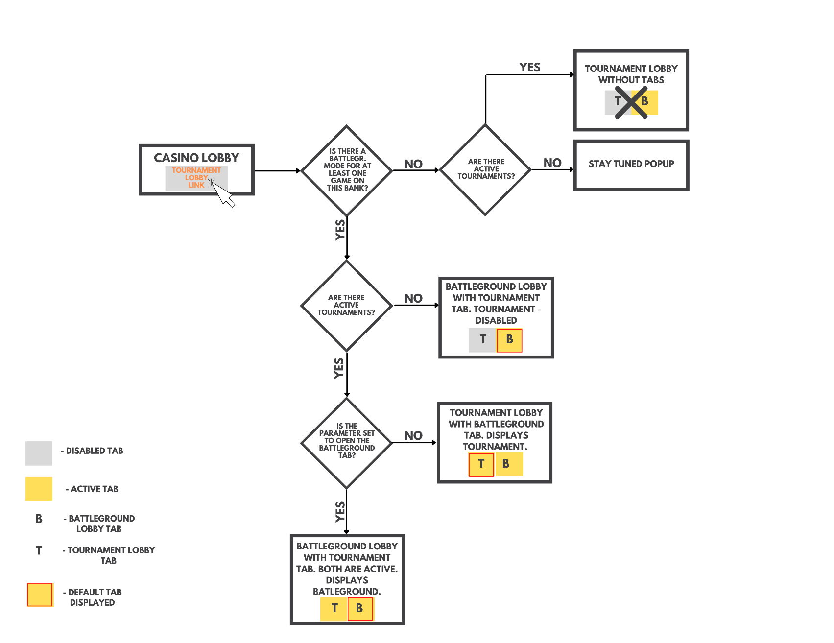

Figure 1. Launching Battleground lobby diagram

The workflow is:
- Player clicks the MQ tournament lobby link
- We check if battleground mode is enabled for at least one game on this bank:
- If no, then we check if there are active tournaments:
- If yes, then current implementation of the tournament lobby without any tabs is displayed.
Example:
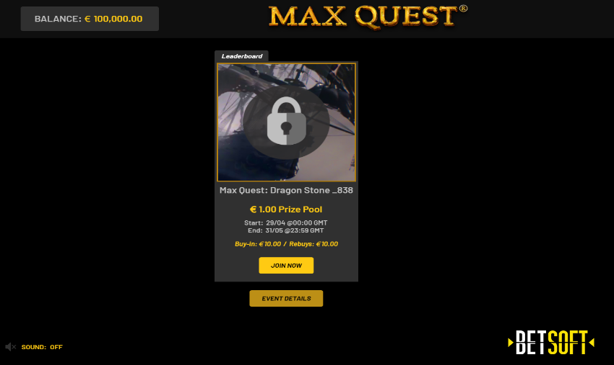
Figure 2. Current implementation of the Tournament lobby

- If no, then “Stay tuned” popup is displayed

Figure 3. Stay tuned popup

- If yes, in any case, first check if there are active tournaments:
- If no, then battleground lobby with tournament lobby tab is displayed. The tournament lobby tab is disabled.
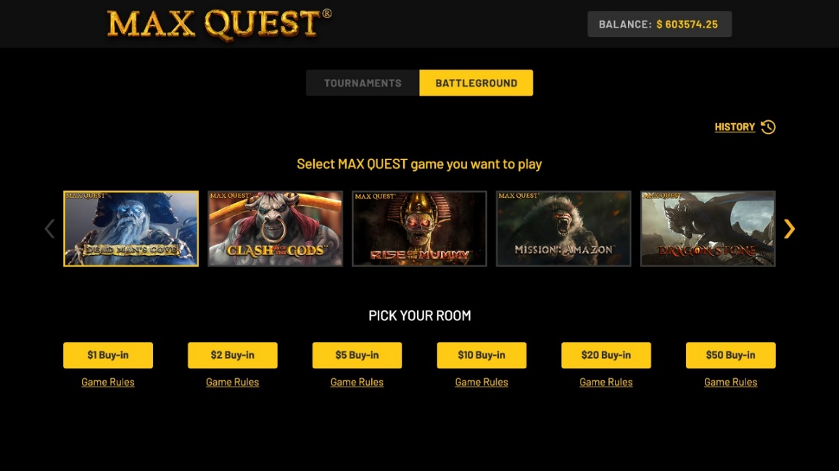
Figure 4. Battleground lobby with disabled Tournament tab

- If yes, then we check is the parameter set to open the battleground tab:
- If yes, then the battleground lobby with tournament tab is displayed. Both tabs are active.
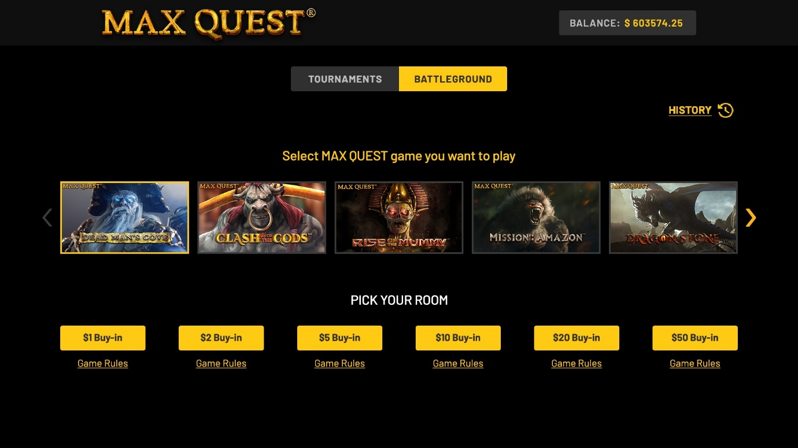
Figure 5. Battleground lobby with both active tabs.

- If no, then the tournament lobby with battleground tab is displayed. Both tabs are active.
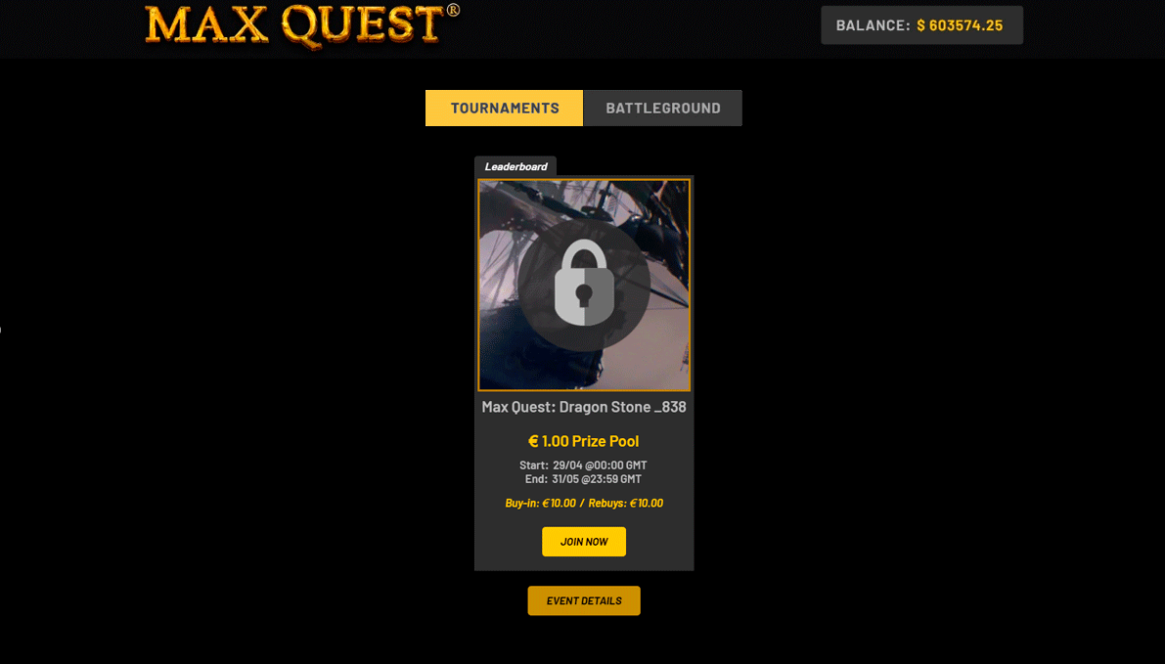
Figure 6. Tournament lobby with Battleground tab. Both are active.

In the picture below, see the mobile version of the Battleground lobby:

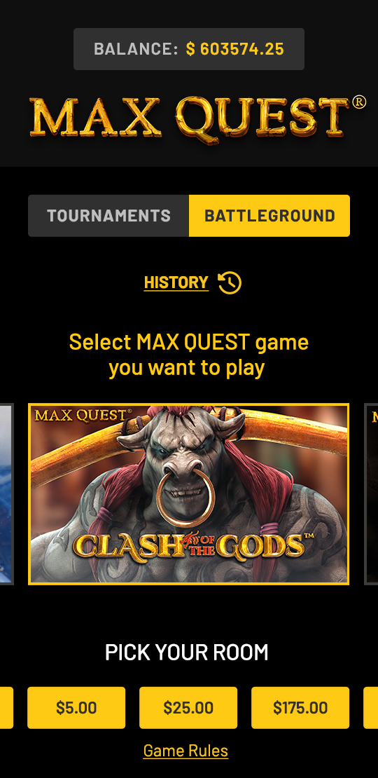
Figure 7. Mobile Battleground lobby

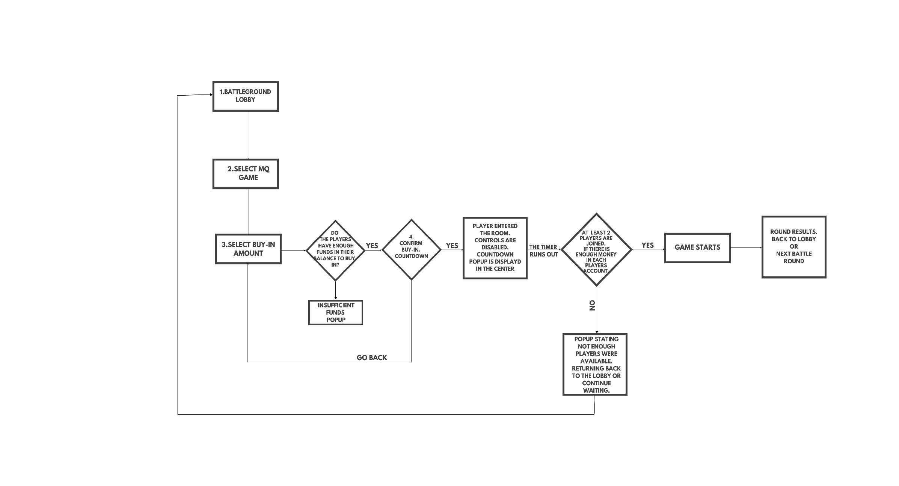
Joining the Battleground from the Tournament lobby
Figure 8. Joining the Battleground workflow diagram
The workflow is:
- Player enters the Battleground lobby. For the player, the games to choose from are displayed, the order of displaying is based on how many active battleground sessions/rooms it has. The most active game is selected by default, sorting from left to right, and all buy-in options are shown. There should always be 6 buy-in options displayed ($1, $2, $5, $10, $20 and $50 or in the appropriate equivalent of the player's currency). If no game has not yet had any active battleground sessions/rooms, the games will be displayed from the new to the old. The first will be highlighted.
It is worth noting that all available buy-in options are displayed for the player. However, if a player does not have enough funds for any buy-ins, when he tries to select such options, a dialog box will be displayed for him, informing him about the insufficient funds (see the step 3).
Battlegrounds in the lobby are displayed for player currency. Players in the same room also have the same currency.


Figure 9. Battleground lobby

- Player selects MQ game.
- Player selects buy-in amount.
This step is used to check the player's balance on the client side. If a player does not have enough money for the buy-in, then he will be shown a popup:
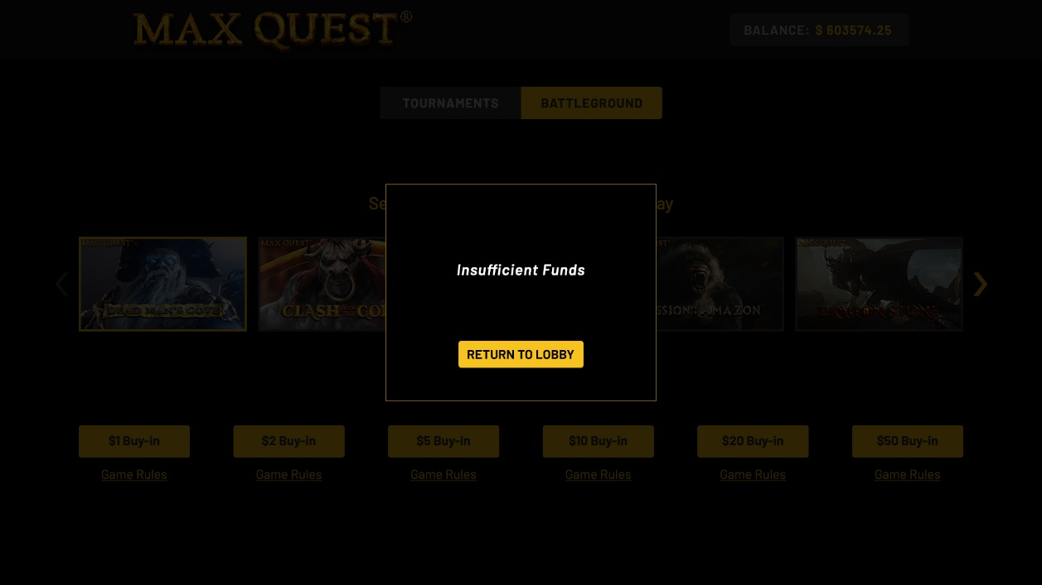
Figure 10. Insufficient funds popup in Battleground lobby

- The pop-up with buy-in confirmation and rules is displayed. The countdown (2 min) until round start will be displayed within the “confirm buy in” popup, each newly joined player will see this countdown.
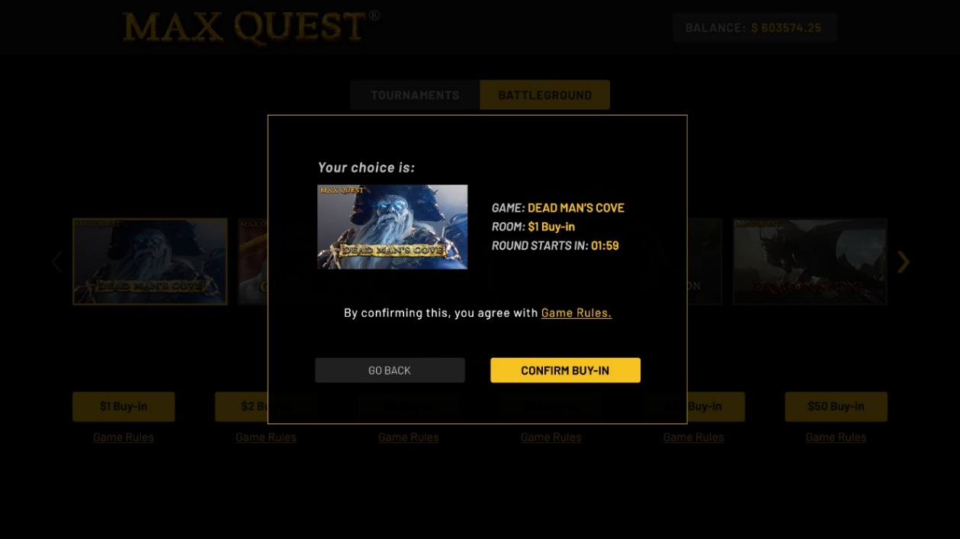
Figure 11. Buy-in confirmation popup

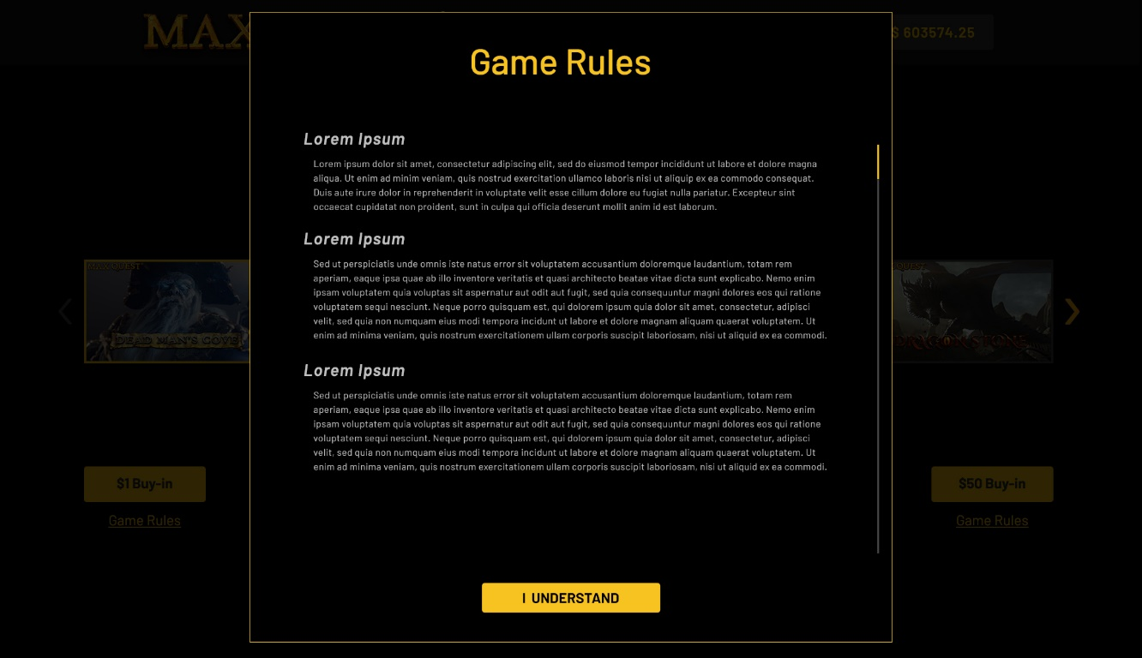
Figure 12. Game rules pop-up

- If the player does not want to continue, he clicks on "go back".
- If the player clicks on «Confirm buy-in», then he is moved to the game room, the controls are disabled. Countdown to the start of the round popup is displayed in the center. The player can change his mind and leave the game before the timer expires.
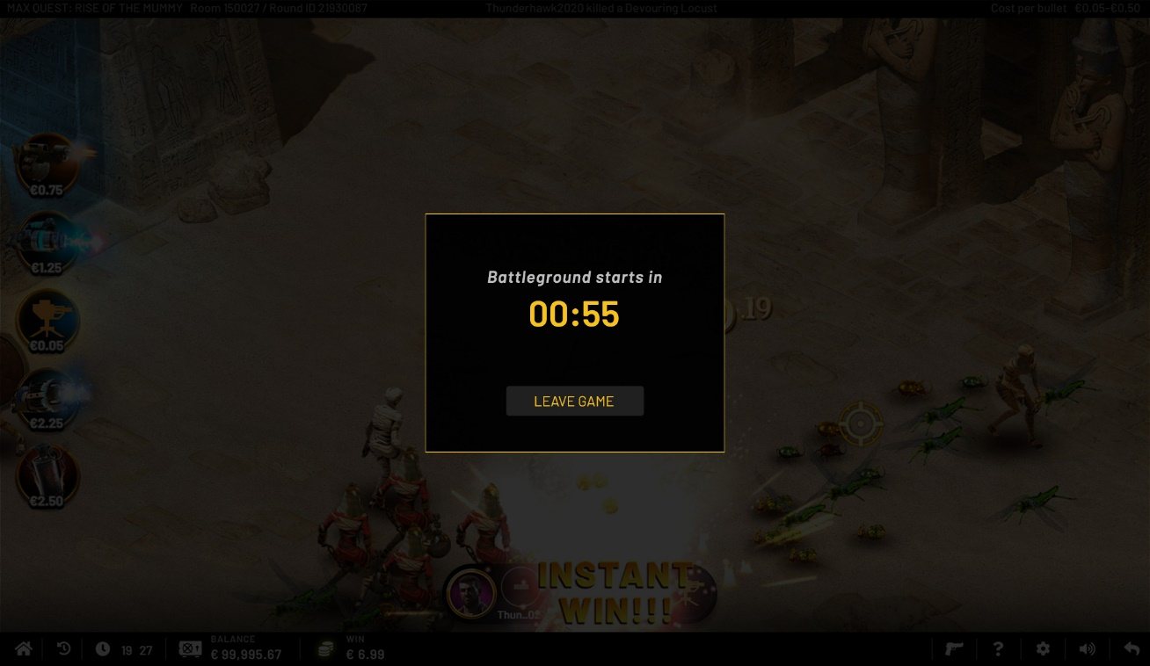
Figure 13. Central timer popup

- If the player has not selected anything, he will be immediately redirected to the game room when the timer expires.

! Note that new players can join the battleground till the end of countdown. If the maximum number of players (6) joins before the timer expires, the round will start immediately

- Once the timer runs out, we check if there are at least 2 players and if there is enough money in each player’s account.
- If yes, then the game will start.
Note that a new player cannot join a round that has already started!
- If no, then the popup stating not enough players were available will be displayed. The player will be returned to the lobby or continue waiting more 2 min.
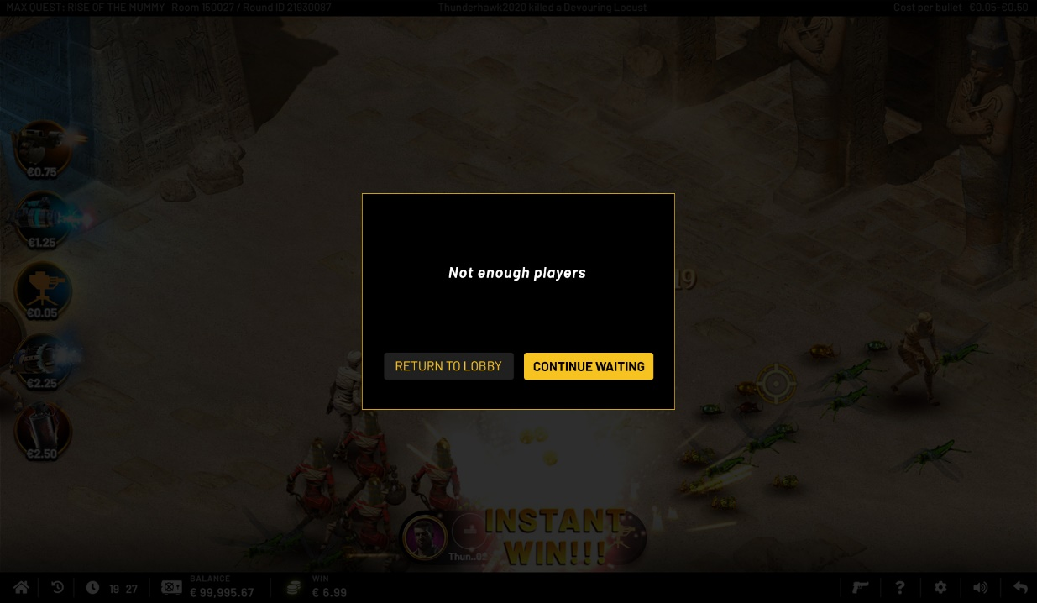
Figure 14. Not enough players popup

- Or if the player's funds might become insufficient (initiated by the player/licensee or server error), then the «Unable to complete buy-in» popup will be displayed.

- After the end of the round, players are shown the results of the round. The player will have two options: «Return to lobby» or «Play again».

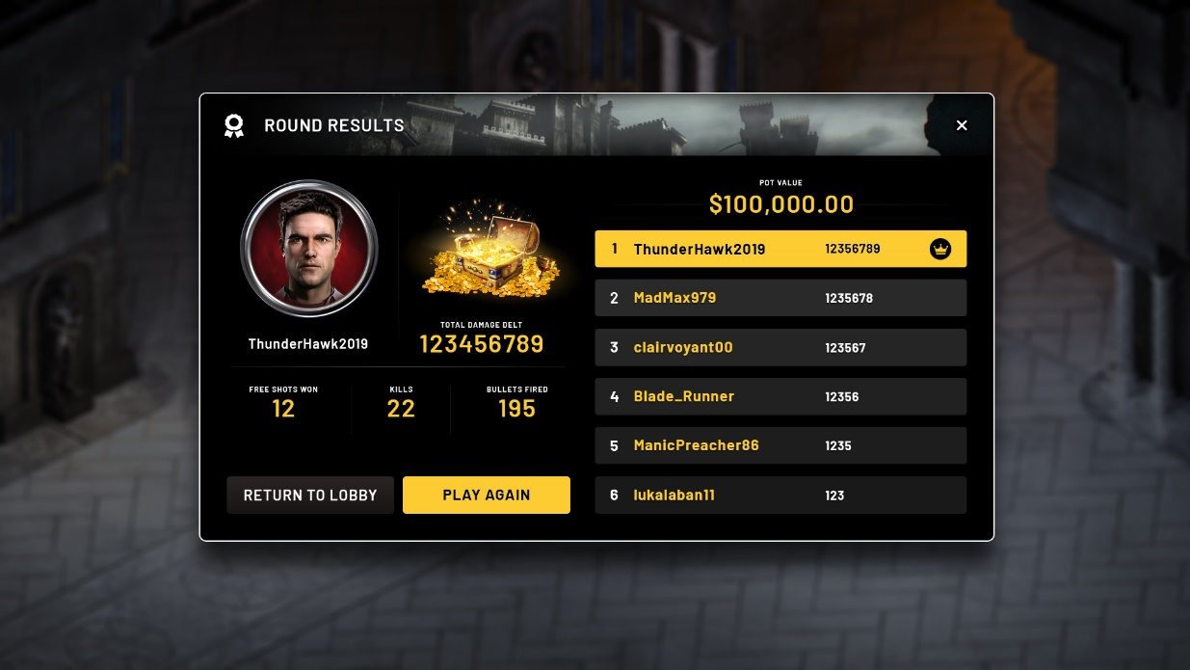
Figure 15. Round results window

- If he clicks «Return to lobby», then he will be redirected to the in-game lobby.
- If he clicks «Play again», then he will be displayed «Confirmation buy-in popup»:
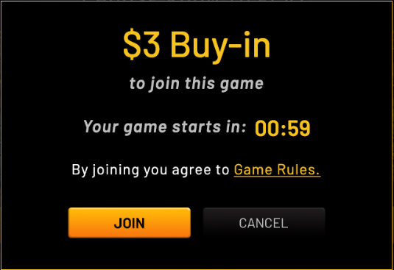

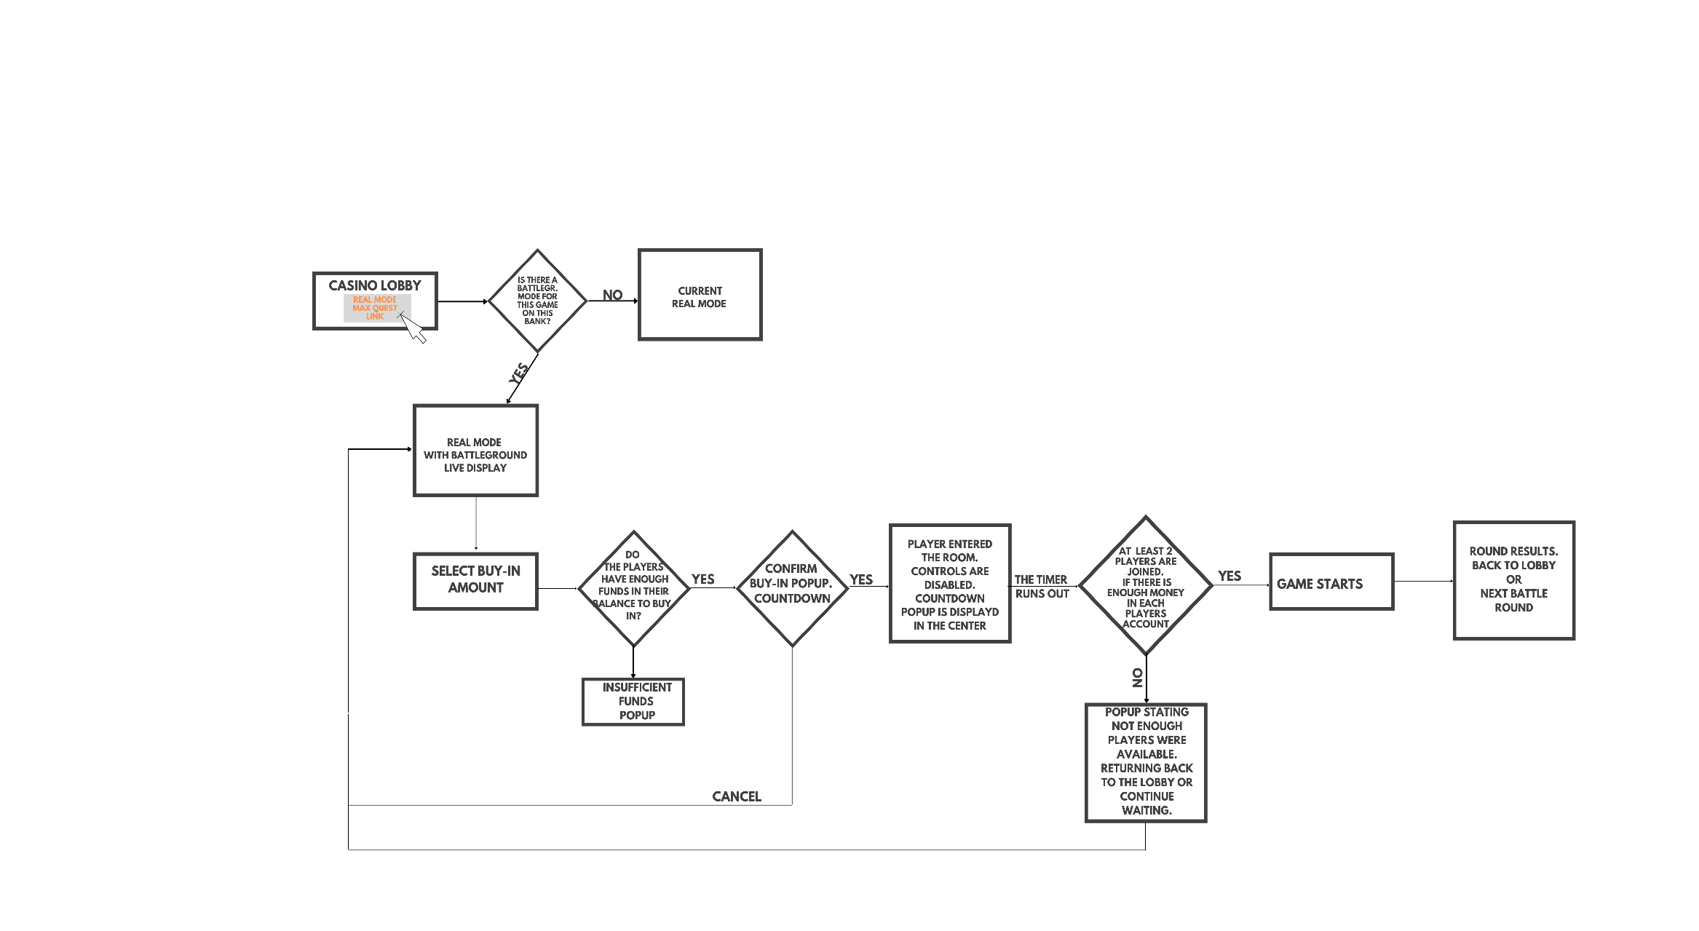
Joining the Battleground from the in-game lobby
Figure 16. Joining the Battleground from the in-game lobby diagram

The workflow is:
- Player clicks the MQ real mode link
- We check if there is a battleground mode for this game on this bank:
- If no, then the current real MQ mode is displayed
- If yes, then the real mode with battleground live display is displayed.
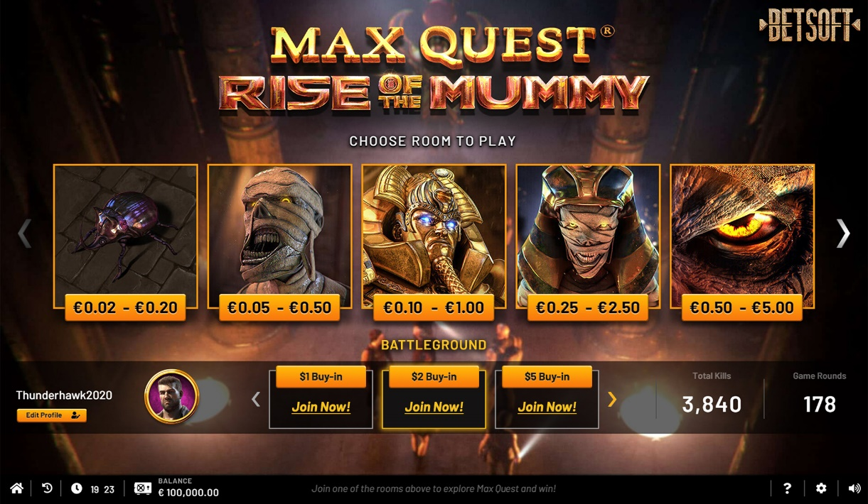
Figure 17. In-game lobby with battleground live display
- The player will be shown a live display with a choice of different buy-in options (also 6 available buy-in options). Player selects buy-in amount. This step is used to check the player's balance on the client side. If a player does not have enough money for the buy-in, then he will be shown a popup:
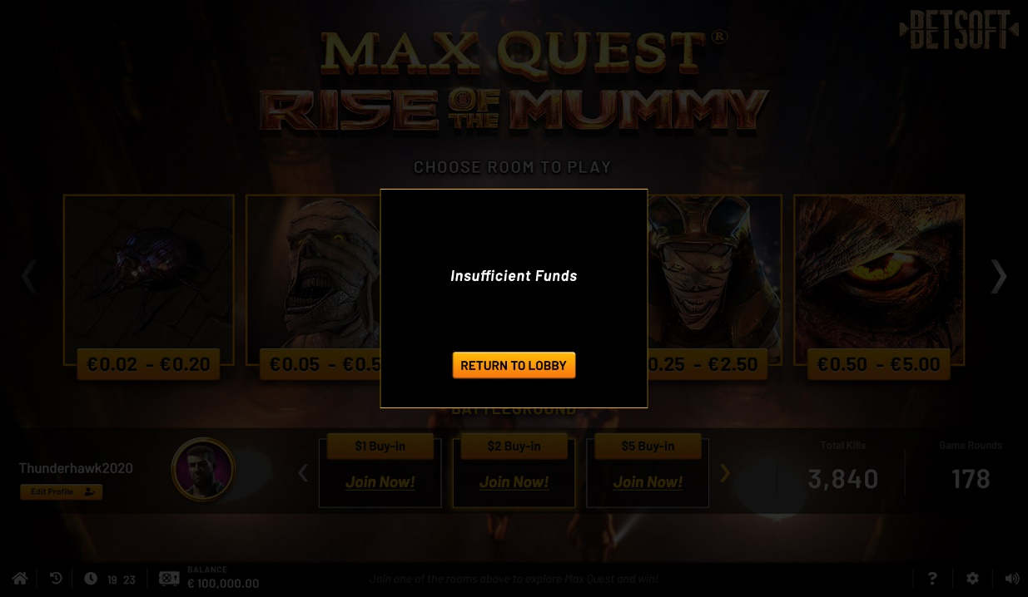
Figure 18. Insufficient Funds popup within in-game lobby

- Players clicks on «Join now! » button directly from the in-game lobby. Then the buy-in confirmation popup with a countdown (2 min) and rules is displayed.
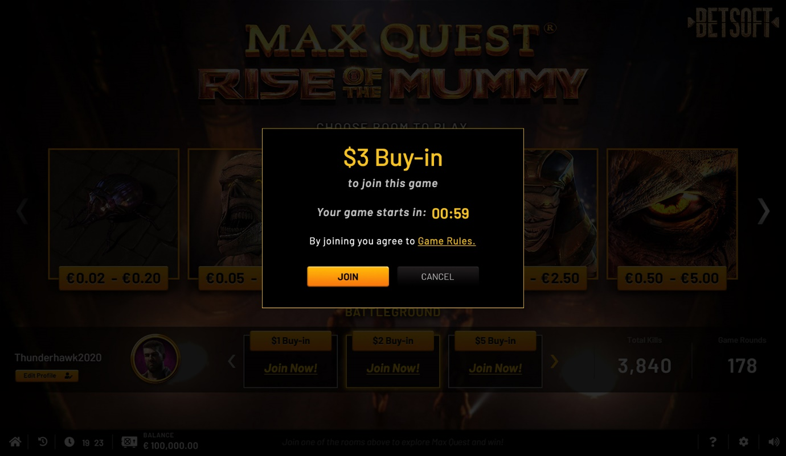
Figure 19. Buy-in confirmation popup from the in-game lobby

- If the player does not want to continue, he clicks on "cancel" and returning to the in-game lobby.
- If the player clicks on «Join», then he is moved to the game room, the controls are disabled. Countdown to the start of the round popup is displayed in the center. The player can change his mind and leave the game before the timer expires.
- If the player has not selected anything, he will be immediately redirected to the game room when the timer expires.

! Note that new players can join the battleground till the end of countdown. If the maximum number of players (6) joins before the timer expires, the round will start immediately.

- Once the timer runs out, we check if there are at least 2 players and if there is enough money in each player’s account. This step is used to check the player's balance on the server side.
- If yes, then the game will start.
Note that a new player cannot join a round that has already started!

- If no, then the popup stating not enough players were available will be displayed. The player will be returned to the in-game lobby or continue waiting more 2 min.

- Or if the player's funds might become insufficient (initiated by the player/licensee or server error), then the «Unable to complete buy-in» popup will be displayed.

- After the end of the round, players are shown the results of the round. The player will have two options: «Return to lobby» or «Play again».
- If he clicks «Return to lobby», then he will be redirected to the in-game lobby.
- If he clicks «Play again», then he will be displayed «Confirmation buy-in popup»:


Gameplay features & restrictions

General
The Battleground mode will be a series of one-round games, continuing permanently. The most important thing to start each round is the presence of at least two players willing to play. Battleground mode will not be tied to a specific start and end date.
The total pot is made up of the players' buy-ins. For the buy-ins players get a certain amount of credits. The player that has the largest balance at the end of the round wins the whole pot (minus % rake). If all players in the round spent all their credits before the end of the round, then the round will end forcibly.

Round’s history
A "History" button will be available for players in the Battleground lobby. The history button inside MQ games is used to open the VAB (Visual Archive Bets), that's linked to certain game.
It assumes Battleground history may show results of different Battleground rounds from different MQ games.

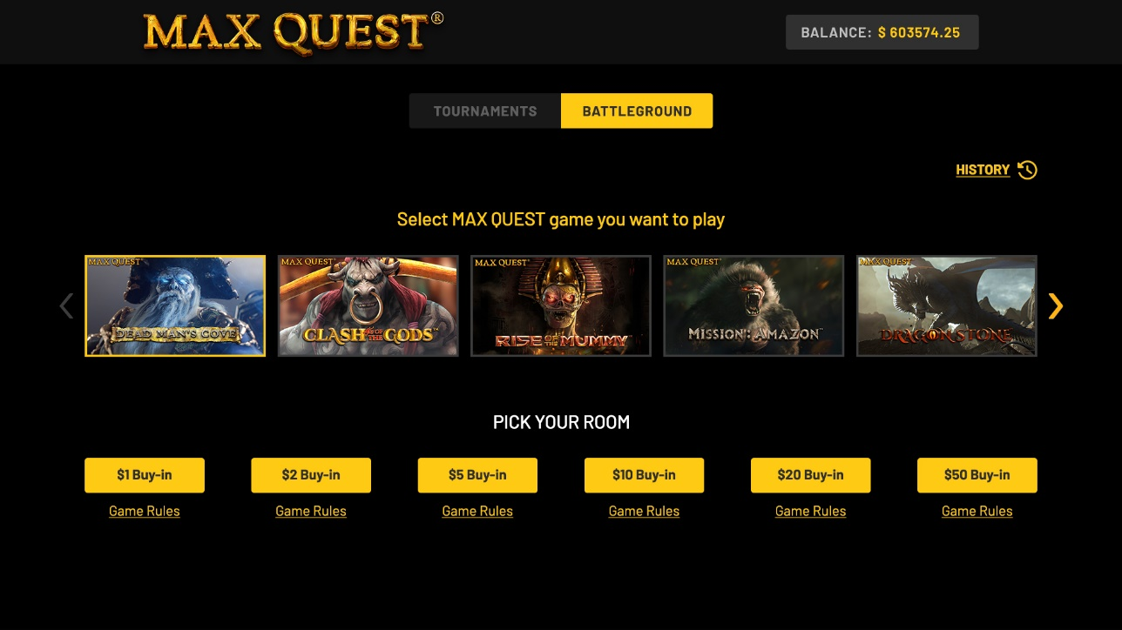
Figure 20. History button in the Battleground lobby

In the Battleground lobby players will be available player's rounds history. The following attributes will be displayed in the history:
- Game name,
- Round ID,
- time and date,
- Status (Live, Ended, Cancelled),
- Players game score,
- Final ranking
- Pot prize won by winner (with the crown next to the players name).

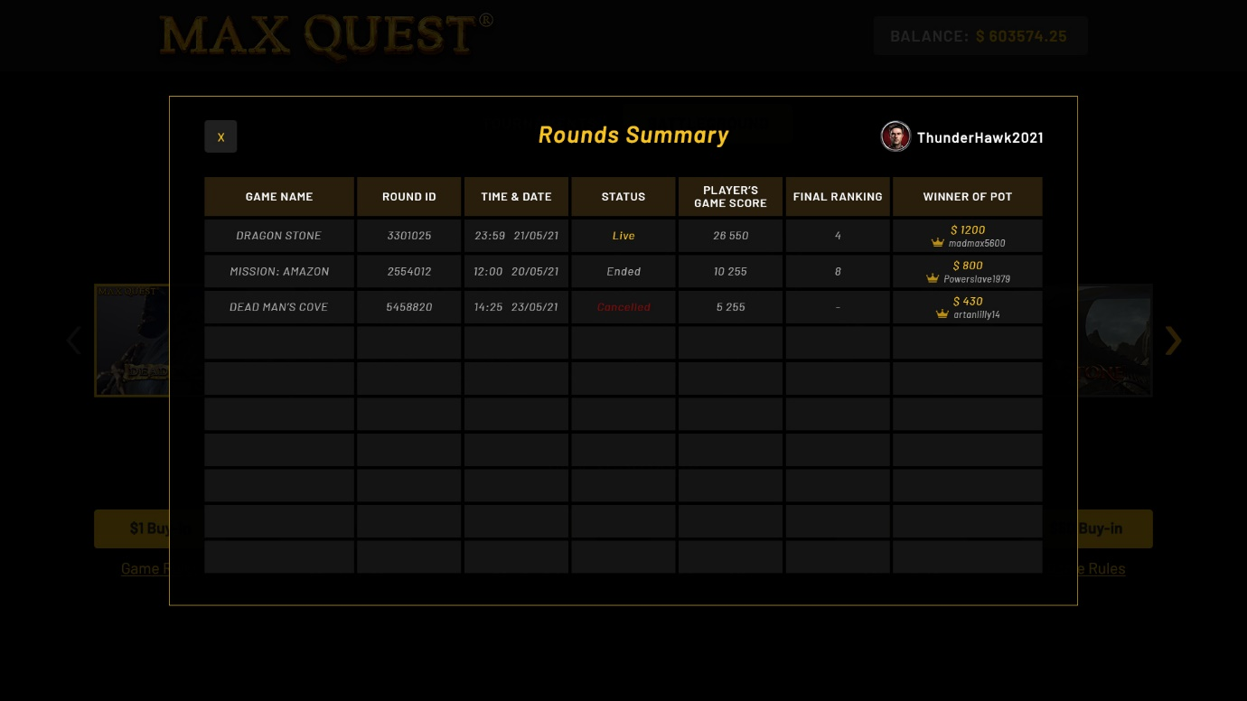
Figure 21. Player’s rounds history

Conditions for debiting and refunding the buy-in
Debiting of the buy-in is performed when:

- the time before the start of the round (2-minute timer) has expired,
- the checking for the minimum number of participants (minimum 2) is successfully passed,
- all participants have sufficient funds to pay the buy-in.

If there is only one player left at the end of the timer, then the buy-in is NOT ACCEPTED and the round is canceled.
If, when checking the balance of players, there is only one player with a sufficient balance, then the buy-in is NOT ACCEPTED and the round is canceled.
Once a player has confirmed his buy-in, he cannot refuse to participate and get his money back.
In the case of a technical error (e.g. connection/ server problems), the round will be canceled and the money will be refunded to all participants.

Special weapon
The participant gets certain amount of credits for buy-in. In addition to shots, he will be able to buy special weapons during the «Battleground» round with these credits.
Weapons not used by the end of the round are not reimbursed.

New symbols
Once the round has started and players have fired the first shot, the «King of the Hill» symbol (currently, the golden crown) is displayed for the icon of the player who wins the most. During the round, the "King of the Hill" is updated and switched between players depending on each player's winnings.

Figure 22. «The king of the Hill» symbol prototype

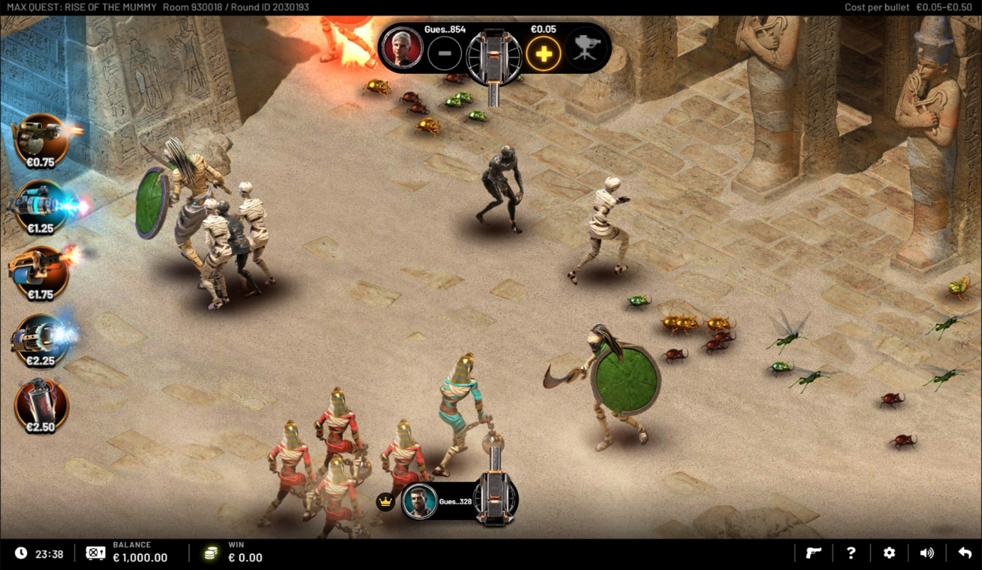
Figure 23. «The king of the Hill» use

Tie breaker arbitration
There are two options for resolving the tie-break:
- The most operative option for implementation is based on the total amount of bets.
- An option that would greatly increase the ETA of implementation is to enable "Sudden Death" mode - short 30-second rounds until a winner is revealed.

Reconnect behavior
If a player accidentally or in some other way closes out a round, then when a player reconnects, no matter where he goes, he is forced to start an unfinished game. This will display «To start a new game session, you need to complete your unfinished battleground session first» popup for him:
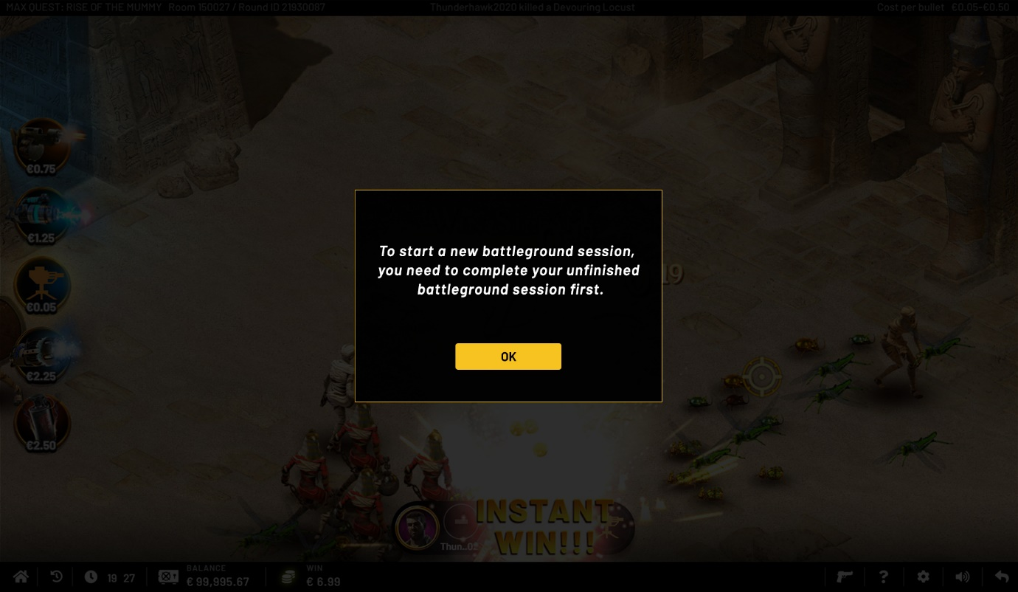
Figure 24. Reconnection pop-up

Reports & Statistic
There should be two reports in the CM for Battlegrounds information. The main report with a sub-report. The main MQ Battlegrounds report should have a list of the Battleground rounds that took place, showing specific MQ game, number of participants, Pot, Rake, etc., and the MQ Battlegrounds Players sub-report should contain information about the participants and their results/ranking.
The following column names are for the MQ Battlegrounds report:
- Round ID,
- MQ game,
- Start time,
- End time,
- Participant count,
- Total Pot,
- Total Pot Won,
- % Rake.
By the transition in the «Participants Count» field you will be directed to the report
«Battleground Leaderboard Winners»:
- Rank,
- Score,
- Ext.ID,
- Is winner (yes/no).

Please, note that at this stage of implementation, enabling Battleground mode will be done through a request to developers. Enabling mode via CM is not yet provided but may be added later on the next phases. The necessary configuration parameters will be determined after experience with manual creation of the Battlegrounds. Battleground rules will be provided by BSG in all required languages and will be uploaded by the developers manually.

